Note: Include this page only when adding / amending / deleting a document. If using this document as a record, this Revision History page can be omitted.

REVISION HISTORY

Revision no | Date | Description of Changes | Reason for Revision | Revised by | Approved by
2 | 01 June 13 | Add revision history page | - Recommendation from Stage 2 audit | RDPlacido
3 | 8 Apr 16 | Added disclaimer when printing the document | For document control | RCGanal | MVBergantin
4 | 26 Feb 18 | Added online survey form via Google form | -Added based on IQA Result for Minor Non-Conformity | JG Adra
TM-BR-MG- 11 Rev02, 10302015

I. Objective
To solicit and determine the attitude of the employees have towards the company based on the pre-determined areas and be able to identify the strengths and weaknesses that the company needs to maintain and improve to attain higher employee satisfaction.
II. Scope
This procedure defines the action and responsibilities of the HR Head in administering online survey forms. This covers activities from the receipt of the accomplished online survey to reporting of the result.
III. Definition of Terms
SurveyMonkey | Is a website where survey forms are created. One can easily design a survey form and the site can collect and analyze the responses.
Google Form | An alternative way where survey forms can be created. Forms created through Google form will be used for employees who can’t access the survey form via Survey Monkey.
Employee Satisfaction Survey Report | - Is a summary report of the number of respondents who participated in the survey, comments of the employees, recommendation to address any issue, action plans that are approved by the ExeCom, the status of the actions made and the end result.

IV. Procedure Details
RESPONSIBLE | ACTIVITY | INTERFACE
HR Head | 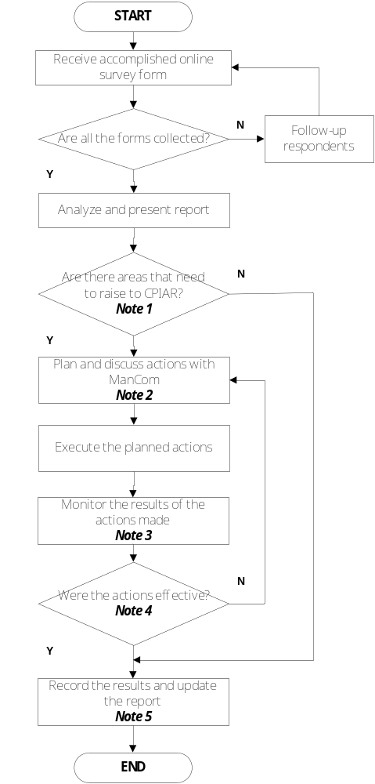 | Survey Monkey Online Form  Google Online Survey Form  Employee Satisfaction Survey Report  ManCom  Employee Satisfaction Survey Report

Notes:
- Based on the result of the survey, if there is negative feedback or areas that are opportunity for improvement, these will be given appropriate attention to address the feedback.
Employee feedback may not be part of this procedure if the comments received are not aligned with the Vision, Mission, Values and Quality Policy of the company, deviates from the existing policies, threatens the financial stability of the company and if it is beyond the control of the company.
- ManCom will plan and discuss the appropriate corrective and preventive actions.
- The person assigned to execute the planned actions is also responsible for ensuring that the actions are executed based on the agreed timeline and resources. HR Head will also closely monitor if it is being done.
- The effectiveness of the action will be based on the any of the following: the concerned parties concurred on the actions made, the immediate cause of the dissatisfaction is eliminated, there is no recurrence of the same issue from the same person within three months and potential recurrence of the same dissatisfaction is redressed.
- The Employee Satisfaction Survey Report is presented to ManCom second Monday of October.

V. References
- SurveyMonkey Online Form
- Google Online Survey Form
- Guidelines for Survey Administration and Results Analysis

VI. Quality Records
- Employee Satisfaction Survey Report

